Lab Report-7

(Sanchit jalan,Group-3,2022101070,Table No:-40)

Experiment 6B:-

Objective:-

Design the circuit for Shift Register and write the code to count from 0 to 255 and glow the 8 LEDs in order with Arduino.

Electronic components required:-

1. Digital test kit
2. Arduino UNO
3. IC 74HC595(Shift Register)

TinkerCAD reference circuit:-

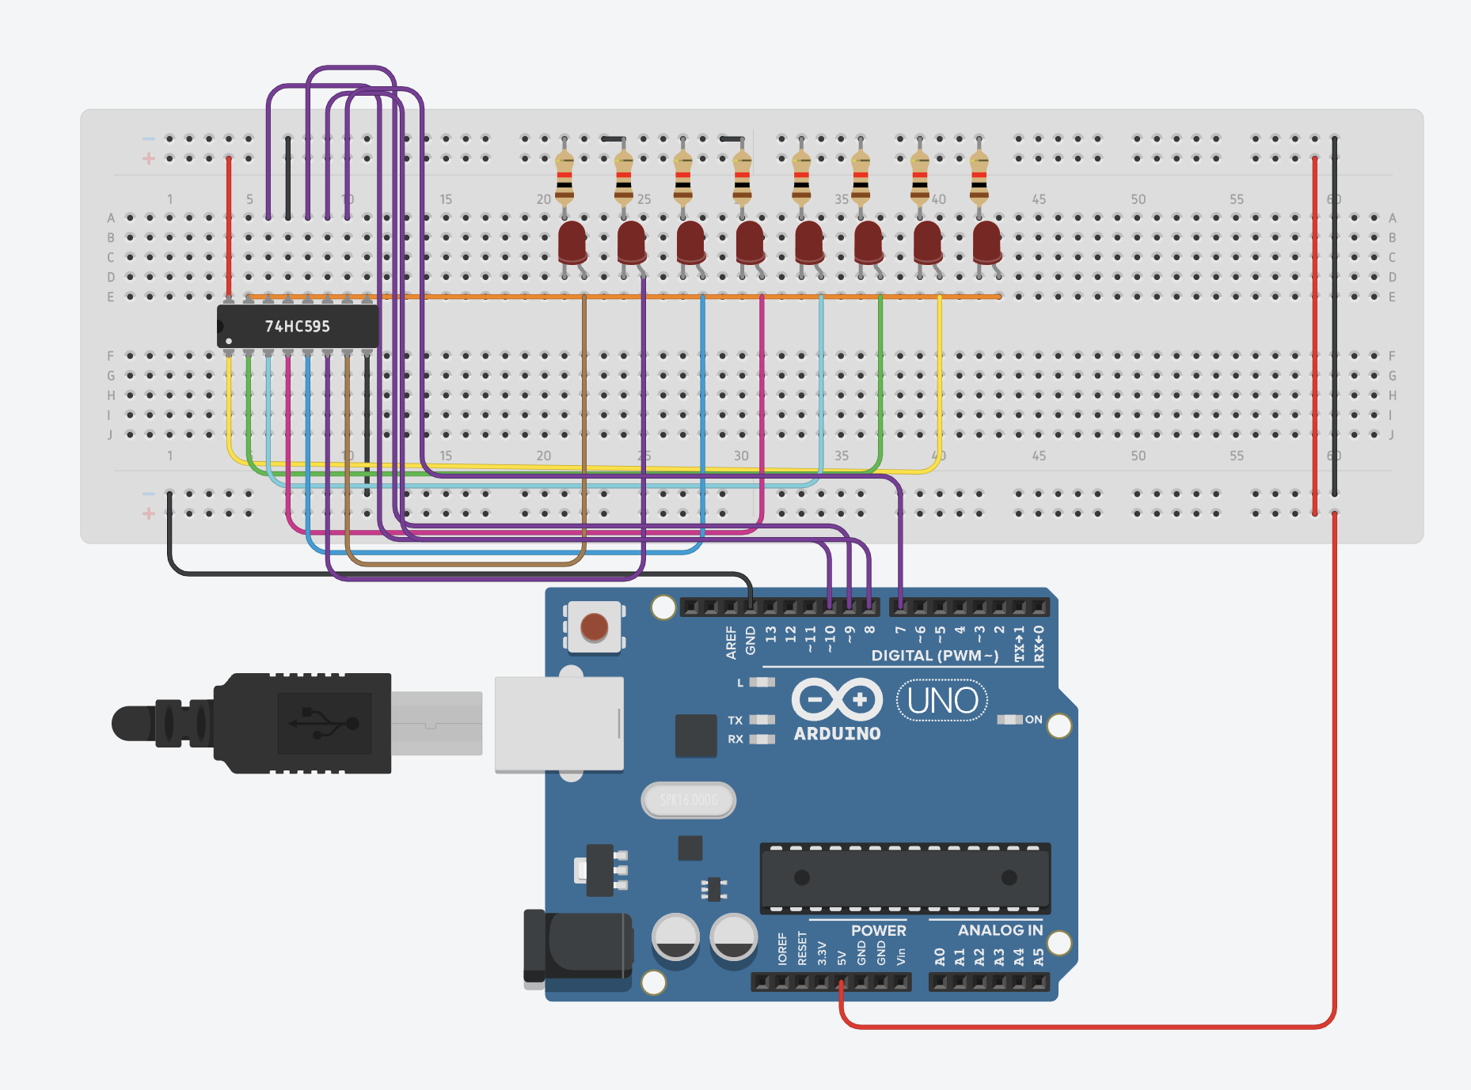

Arduino Code:-

int shift_clr=7;  
int shift_clk=8;  
int latch_clk=9; int serial_data=10;

void setup() {

pinMode(latch_clk, OUTPUT); pinMode(shift_clk, OUTPUT); pinMode(serial_data, OUTPUT);

digitalWrite(shift_clr, HIGH); }

void loop() {

for(int i=0;i<256;i++) {

digitalWrite(latch_clk,LOW); shiftOut(serial_data,shift_clk,MSBFIRST,i); digitalWrite(latch_clk,HIGH);  
delay(500);

}

}

Procedure:-

1) Power IC 74HC595 by connecting it to VCC and GND with red and black wires respectively. You can also connect Shift Clear Pin (Pin No. 10) at HIGH/VCC so that outputs do not reset during its operation.

2) IC 74HC595 takes in 1 Serial Data Input(Pin No. 14) and gives 8 Outputs by the operation of Shift Clock(Pin no. 11) and Latch Clock(Pin No. 12). Provide input for these pins by Arduino and access these inputs with an appropriate code and using the shiftOut operation.

3) At the positive edge of Shift CLK, bits are transferred in shift register(1 bit in one triggered edge), and on the positive edge of Latch CLK, 8 bits stored in the shift register are transferred in the latch as outputs and these outputs can be accessed by connecting Pin No.s 1-7 and 15 to LEDs.

Observation:-

LEDs start glowing in such a manner that it can be interpreted as a counter from 0 to 255 and resets when it reaches 255.

The time period of Bit 0(LSB) is 0.5 sec and increases by a factor of 2 as we move to more significant bits. The whole count is done in 128 seconds.

Conclusion:-

We have formed a counter from 0 to 255 using Shift Register and Arduino.

**Experiment 6C:-**

Objective:-

Design the circuit for Shift Register and write the code to take input from the user (range 0-7) and glow the corresponding LED.

Electronic components required:-

1. Arduino UNO
2. Digital test kit
3. IC 74HC595 (Shift Register)

TinkerCAD reference circuit:-

Arduino Code:-

int shift_clr=7;  
int serial_data=10; int shift_clk=8;  
int latch_clk=9;

void setup() {

pinMode(latch_clk, OUTPUT); pinMode(shift_clk, OUTPUT); pinMode(serial_data, OUTPUT);

digitalWrite(shift_clr, HIGH);

Serial.begin(9600); }

void loop() {

int x=1;  
Serial.println("Input= ");  
while (Serial.available()==0){} int i=Serial.parseInt(); Serial.print(i);

for(int j=0; j<i; j++) {

x=x*2; }

digitalWrite(latch_clk,LOW); shiftOut(serial_data,shift_clk,MSBFIRST,x); digitalWrite(latch_clk,HIGH);  
delay(500);

}

Procedure:-

The procedure for this part is like the one in 6(b) except you need to write a different code to access only one Output Bit at a time and that bit needs to be specified by the user (input constraint from 0-7). For example, if the user wants to access Bit 5, the LED corresponding to Output Bit 5(LED No. 6 if indexing of LED starts from 1) should glow.

Observation:-

Arduino takes an input(bit that is required as a single output) ranging from 0 to 7 from user and glows the LED which represents the index of the bit.

Conclusion:-

We have formed a Bit Selector using Shift Register and Arduino.

Experiment 7:-

Objective:-

To implement and verify the operation of a Binary cell for RAM based on RS flipflop.

Electronic components required:-

1. Digital test kit
2. Wires
3. NOT gate
4. Triple input AND gate
5. NOR gate

TinkerCAD screenshot:-

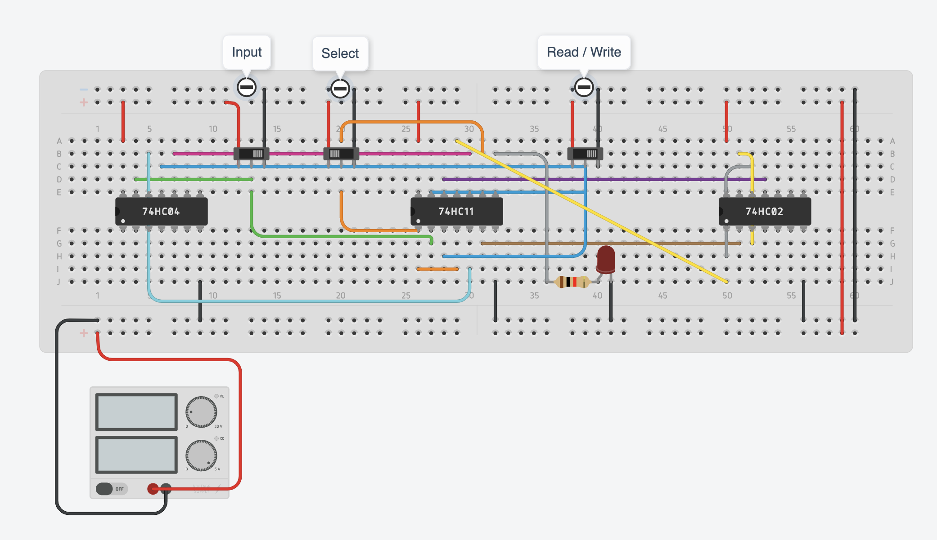

Reference circuit:-

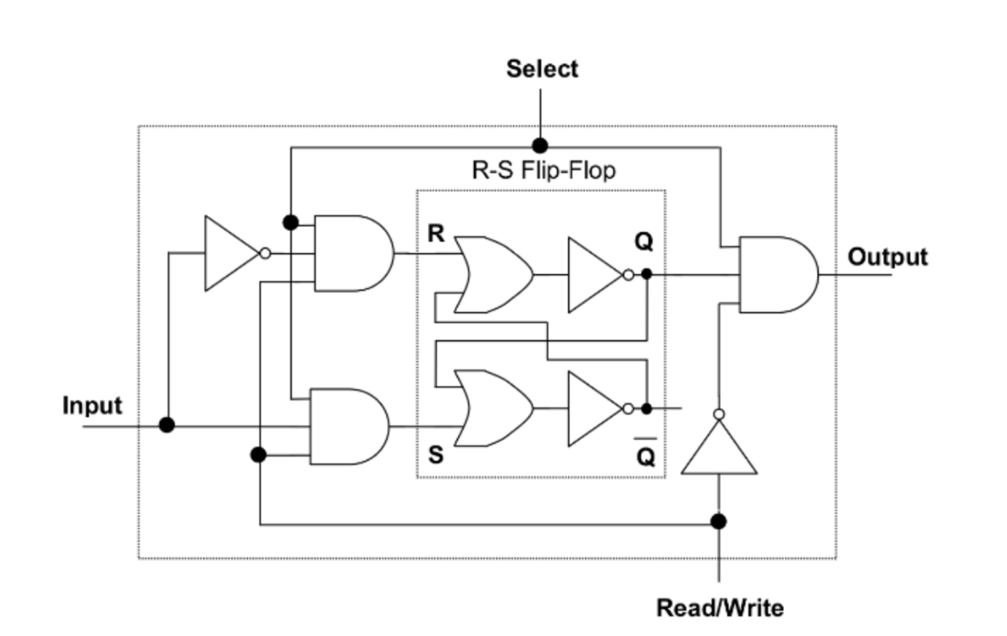

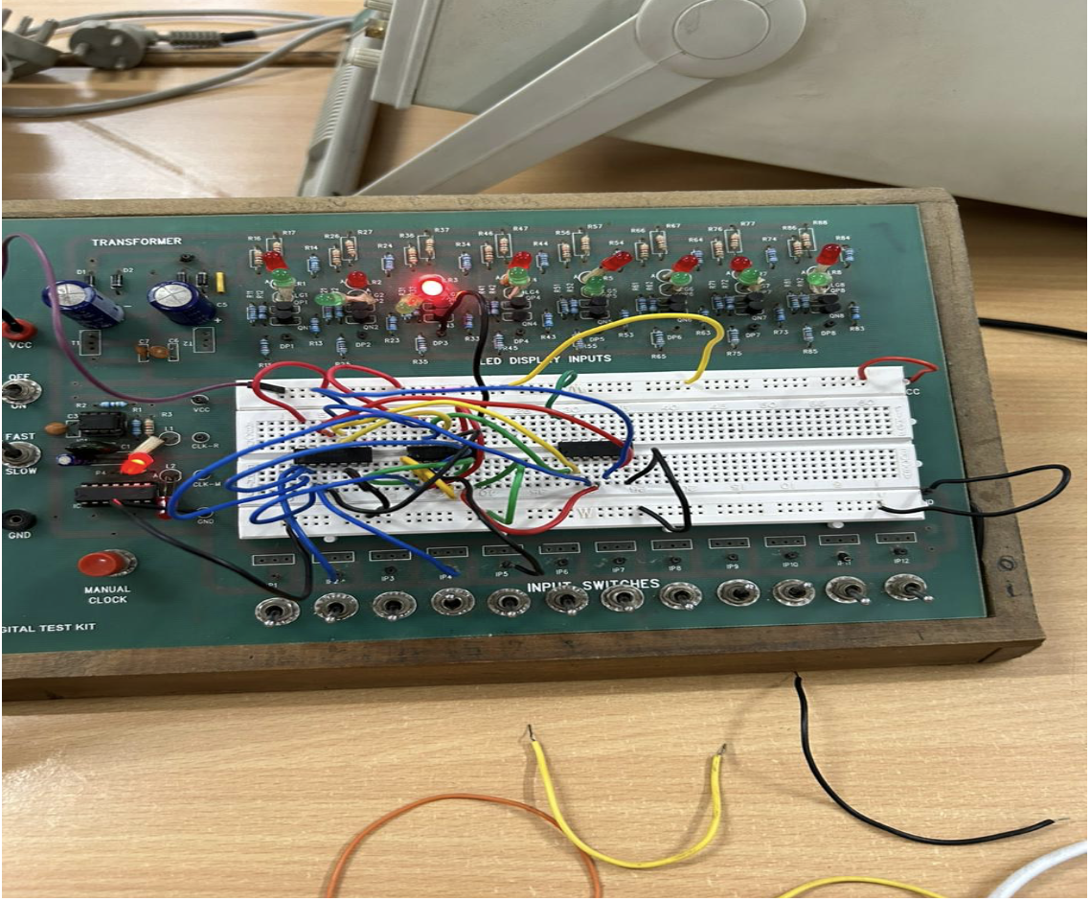

Procedure:

1. Attach 2 Triple input and gates , 1 NOT gate and 1 OR gate IC to the breadboard of the digital test kit.

2. Connect the VCC and GND of the ICs to the digital test kit

3. Assemble the RS flipflop as given in the reference circuit using the NOT and OR gates.

4. Take three input from the digital test kit (IP1-IP3) and assign them as Input , Read/Write, Select lines for the binary cell

5. Take the AND of output of RS flipflop , Select line and complement of Read/write line and connect it to DP1 Led of the test kit

6. Turn on the power supply and observe the output .

Observation:-

|  |  |  |  |
| --- | --- | --- | --- |
| Input | Select | Read(0)/Write(1) | Output |
| 1 | 0 | 1 | 0  (No operation) |
| 0 | 1 | 1 | 0  (Writes 0) |
| 1 | 1 | 0 | 0  (Reads 0) |
| 1 | 1 | 1 | 0  (Writes 1) |
| 0 | 1 | 0 | 1  (Reads 1) |
| 1 | 0 | 0 | 0  (Binary cell disabled) |
| 1 | 1 | 0 | 1  (Reads input before disabling the cell) |
| 0 | 1 | 1 | 0  (Writes 0) |
| 0 | 1 | 0 | 0  (Reads 0) |
| 0 | 0 | 0 | 0  (Select line disabled) |

Conclusion:-

A Binary Cell has been implemented and its operations has been verified.